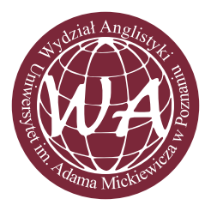
The Faculty of English
Adam Mickiewicz University
Poznań, Poland
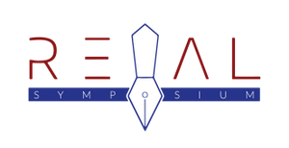
Department of American Literature at the Faculty of English, AMU, Poznań
and
American Studies Section of the Scholarly Circle at the Faculty of English, AMU, Poznań
Book Lovers Among Students (BLASt)

4th Re-Examining American Literature Student Symposium (REAL)

CALL FOR PAPERS

Visions of the Future in American Literature and Culture

March 17, 2018
The Faculty of English, Adam Mickiewicz University, Poznań

“The disruption of the anticipated American future that was simply to have unrolled out of the solid American past, out of each generation’s getting smarter for knowing the inadequacies and limitations of the generations before out of each new generation’s breaking away from the parochialism a little further, out of the desire to go the limit in America with your rights (...).”

― Philip Roth, American Pastoral

The 4th REAL Student Symposium seeks to explore the future as a concept, an ideal, and an ideology. The United States, as a nation that always looks ahead trying to reinvent itself, enjoys a troubled relationship with both its past and its future. We are interested in ways in which the future(s) of America conjured up in literary and cultural texts reflect and comment on the current state and possible developments in the United States. Our keynote speaker will be dr Agata Zarzycka (Wroclaw University) – a specialist in posthumanist studies, fantastic and speculative literature and the author of the monograph Socialized Fiction: Role-Playing Games as a Multidimensional Space of Interaction between Literary Theory and Practice (2009).

We cordially invite B.A. M.A. students and doctoral candidates, to submit conference papers (approx. 20-minute presentations) on American literature, theater, film and art, concerning (but not restricted to) the following issues:

- Utopias and dystopias
- Political science fiction
- Science fiction and poetry
- Escapist fantasies
- Changing visions of nationhood
- The future of American literature and culture
- Future myths
- The future of humanity, post-humanism
- Virtual reality
- Environment and space
- Futuristic narratives and forms
- Gender, race, ethnicity and the future
- Literary theory and the future

Please send an abstract of 200-300 words, stating also your name, email address and institutional affiliation by February 20th, 2018 to: molsza@wa.amu.edu.pl.
All submissions must include a 100-word biographical statement.
All queries should also be sent to the above address.
The conference fee is 150 PLN (includes conference materials, coffee breaks and lunch; accommodation is not included)
Website: http://bookloversamongstudents.webs.com/real-symposium
The venue:
Collegium Novum
The Faculty of English
al. Niepodległości 4
61-874 Poznań, Poland
REAL Organizing Committee:
Chair: dr hab. Paulina Ambroży, prof. UAM
Chair: dr hab. Paweł Stachura, prof. UAM
Secretary: dr Małgorzata Olsza
Student help: Izabela Tomczak

