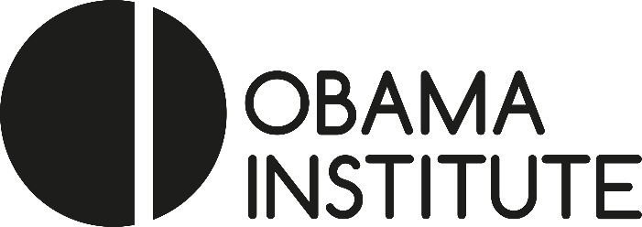 |  | 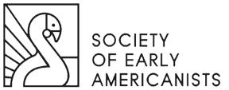

Call for Papers:
“Transatlantic Conversations: New and Emerging Approaches to Early American Studies”

A Workshop Jointly Sponsored and Organized by the Obama Institute for Transnational American Studies and the Society of Early Americanists

October 4-6, 2018
Johannes Gutenberg University, Mainz, Germany

The discipline of early American studies seems full of gaps: from Eric Slauter’s perceived trade gap between historians and literary scholars (Early American Literature, 2008) to the theory gap between early American literature and later disciplines identified by Ed White and Michael Drexler (American Literary History, 2010). Given the boon of transatlantic scholarship in the past few decades, however, the relationship between European and North American scholars working on early Americanist topics appears to grow closer than ever before. A small but stalwart group of European—especially French, German, Austrian, Swiss, and British—early Americanists regularly attends North American conferences, such as the SEA biennials and the annual ASA convention. In turn, however, too few North American scholars are reading scholarship published and attending scholarly gatherings in Europe.

This joint Obama Institute-SEA workshop will bring together early Americanist scholars from North America and Europe in a 2 ½-day intensive conversation and collaboration about transatlantic perspectives on new developments in the field of early American studies. The workshop seeks to engage several critical fields around which specific collaborations during the conference will center:
- Digital humanities and archival studies
- Intersections between book history, print and material culture
- Transpacific and archipelagic studies
- Indigenous studies
- African American studies
- Periodical studies
- Ethnic, multilingual, and comparative literary studies
- Environmental and medical humanities; history of science
- Religious networks
- Post-critique
- Aesthetics and new formalism
Seminal critical interventions—such as Elizabeth Anker and Rita Felski’s Critique and Post-Critique (Duke, 2017) or Ed Cahill and Ed Larkin’s focus on aesthetics in their jointly edited issue of Early American Literature (2016)—frequently catalyze new work in early American studies on both sides of the Atlantic. Yet scholars in Europe and North America often apply theoretical questions in different ways and proceed from different assumptions about the aims, methods, and rhetorical articulations of scholarly and critical innovation. Even more basically, varying practices of reading and teaching, or uses of text, context, and critique often make conversations at standard conferences non-starters or inconclusive. This workshop provides early American literature scholars the opportunity to
- Discuss their work with scholars across the Atlantic.
- Debate applications of key critical texts in their field to early American studies.
- Plan collaborative publications, grants, workshops.

The Workshop will be limited to 30 participants grouped together in small, critically and thematically focused teams. Each team works together over 2 days and shares results in poster presentations at the end of the workshop. Preceding the Workshop, each pre-arranged team agrees upon, circulates, and reads a) one article-length work in progress written by each participant, and b) a limited number of critical/theoretical works informing each sub-field to anchor the conversation and collaboration.

Submissions
Please email the following materials to the Workshop Chair, Prof. Oliver Scheiding (scheiding@uni-mainz.de) as PDF attachments by February 15, 2018:
- A 2-page CV.
- A circa 400-500 word proposal, including the applicant’s critical and theoretical focus, current work(s)-in-progress, past and future work in primary text archives, and a statement detailing specific objectives and ideas for scholarly collaboration. The proposal should address how and why the applicant’s work would profit from collaboration with colleagues across the Atlantic. Although the main Workshop language will be English, all applicants should detail their level of competency in languages other than English (such skill will not be required but may help in grouping applicants in specific teams).

Workshop acceptances will be sent out by March 15, 2018.

